User manual of BS-836A electric three function hospital bed
Grateful for using Bossay’s electric bed, pls read this manual carefully before operating.
- Product summarize
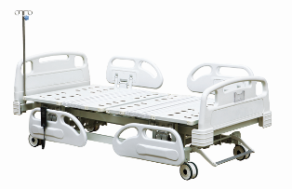

  - Product composition:
Overall size:2120*970*450/700mm
Material： ▪ ABS head and foot board,antisepsis,anti-oxidation,generous in appearance. ▪ The bed platform is made of cold roll steel sheet,shaped at one time; ▪ The frame is welded by steel tube,stable and reliable;surface treatment:electrostatic powder coating ▪ PP tuck away siderails,generous in appearance,stable and easily operated. ▪ The system uses Taiwan Timotion ,the safety voltage motor
Standard Configuration:
▪ Advanced medical motor system(3 pcs motors,1 pcs control box,1 pcs wireless control handle)
▪ Urine hooks,I.V drip ▪ Bed board with flexible connection ▪ Central-controlled castor brake system

- Working status

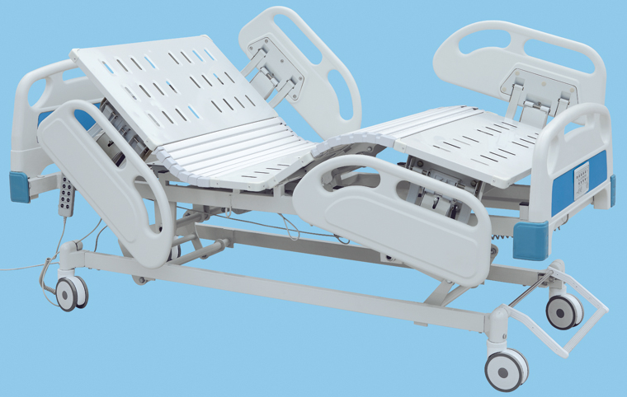
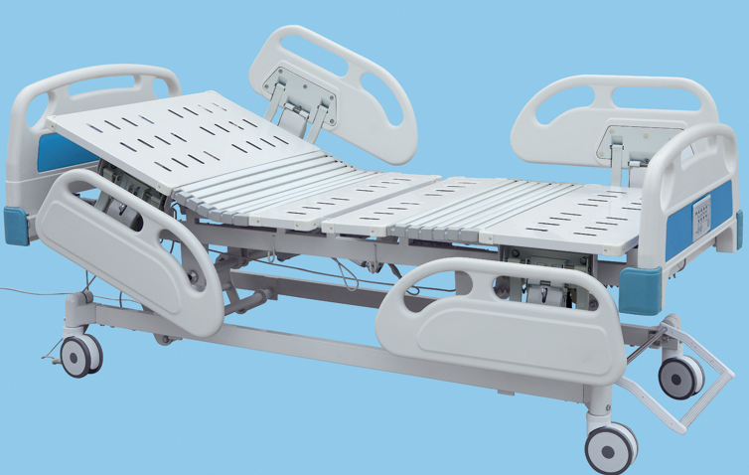
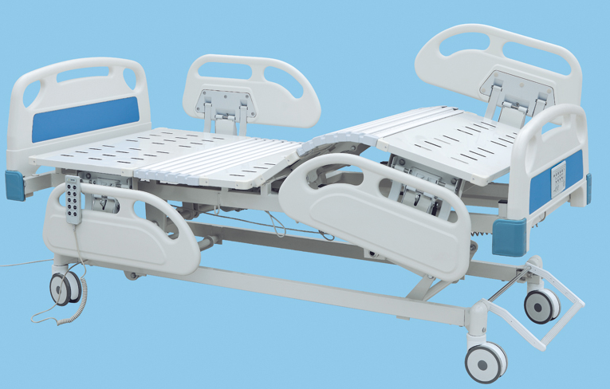

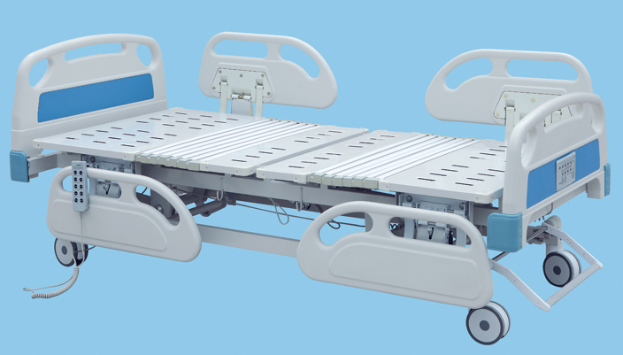

BS-836c Luxurious Electric Bed with Three Functions
Product structure characteristics and working principle introduction:
- Electric Bed consist of five parts:bed board(include back board,fixation board,leg board,baseboard),bed frame,ABS bed head board and foot board,PP guardrail and base support.
- Controller.Lifting height of bed surface,Conditioning back board and leg board angle
- Hospital bed with PP guardrail,protect patients safety.
Name | Description
Bed Frame | Consist of carbon steel pipe,carbon steel angle and carbon steel plate  Using carbon steel pipe 60*30*1.5、50*50*1.5  Carton steel angle 30*30*2.5
Bed Surface | Using cold rolled steel 1.1mm steel stamping,stretch forming,  bonding forming
Bed head board and foot board | ABS bed head board and foot bord  Color:Blue
Castor | Central-controlled system,lock the four coaster at the same time
Motor | Imported from TaiWan
Optional:
Side rail | PP side rail
I.V Stand | Urine hooks 4 pieces,  Height adjustable from 900mm to 1700 mm  Material:Stainless Steel
Product Feature and technical parameters:
bed board size | 1900*900mm
Height adjustable | from :450 to 700mm
Back-rest lifting angle | 0～80°(±5°)
Knee-rest lifting angle | 0~40°(±5°)
environmental requirement | ambient temperature:5℃～40℃  relative temperature≤80℃  atmospheric pressure 86～106kpa
Power Supply | AC220V,50HZ
controller voltage | DC24V
Overall size | L2100*W910*H450mm
warranty period | Under the condition of compliance with products storage and operating requirement,from the date of delivery within 12 months, as a result of product quality problems caused by equipment failure,repair and replacement part for free

Installation, commissioning:
- After unpacking check the packing list
- Put the bed frame to its place
- Push the hospital bed should be light and flexible,with the feet on the break roller,Raise
the brake can loosen the roller,push the bed.
- Press on the bed board raise up key,bed board rise,loosen the key, bed board reach the aim height
And stop movement;Press on the bed board fall key,bed board go down;When it reach the highest or lowest position(raise up to 700mm,fall up to 450mm),motor will stop moving.
- Press on the back board raise up key,back board rise,loosen the key,back board reach the aim height;Press on the back board fall key,back board go down;When it reach the highest or lowest position(raise up to 80°,fall up to 0°),motor will stop moving.
- Press on the leg board raise up key,leg board rise,leg board reach the aim height;Press on the leg board fall key,leg board go down;when it reach the highest or lowest position(raise up to 40°,fall up to 0°),motor will stop moving.

Notes:
- Operate the hospital bed by the special training medical staff
- Be sure not to self-operated the hospital bed by patient,avoid damage.
- Use spay disinfect the hospital bed
- Hospital bed dynamic security bearing ≤180kg,Static security bearing≤250kg,
prohibit over load
- Preventive Maintenance at a fixed time,avoid the mechanical failure
- Drive system should be maintenance for every two year.
- After fixed the position,step on the brake roller,avoid the beds moving.
- When nobody use the hospital bed,put the bed board into the lowest position,and cut off
The power supply.
Transportation & Storage:
- Transportation requirement as stipulated in the contract
- Storage requirement:relative temperature≦80º,No corrosive gas, room with good
Ventilation
Notes,Caution and Instruction:
- Hospital bed dynamic security bearing≤180kg,Static security bearing250kg
- Should be brake two rollers when stop at any place,ensure the bed will not move.
- Ensure the bedboard be setted to the lowest position,when nobody use the bed.
- Try to reduce the load when adjust the angle
- Check and maintain the bed every year,oil renewing
- Daily cleaning maintenance,use neutral synthetic washing agent,wet cloth wipe,and
Dry cloth wipe clean
- Do not contact with strong acid, strong alkali, prevent erode
- Put the bed into lowest position when nobody watch the patient
- Do not press the power supply cord ,when the hospital bed is moving,avoid
The insulation broken;No collision,extruding bed head board and foot board when
moving the beds.
Maintenance and storage method：
- Do not overload,frequently regulation Angle
- Periodic inspection according to the operating environment,when abnormal voice,should check the reason and removal the fault.
- When the brake roller broken,should change the castor.
- Product should be stored in relative humidity of no more than 80º,No corrosive gas and
in good indoor ventilation
- People can not sit on the bed head board and foot board,avoid the Security incidents
- When back board and head board raise up,the max load is 25KG,avoid it out of shape.
